****UNIT 3: HARDAWARE: THE KEYBOARD AND PERIPHERALS

**USEFUL VOCABULARY 3**

KEYBOARD

* Alt key
* Arrow keys
* Backspace key
* Caps lock key
* Command key
* Control key
* Delete key
* Escape key
* Function keys
* Modifier key
* Numeric pad
* Return or enter key
* Shift key
* Space bar
* Tab key
* Letter keys

PUNCTUATION SYMBOLS

* And symbol
* Apostrophe
* Asterisk
* At symbol
* Brackets
* Colon
* Comma
* Exclamation mark
* Full stop
* Hyphen
* Question mark
* Quotation marks
* Semicolon
* Slash
* Underscore

PERIPHERALS

* Barcode scanner
* Flash drive
* Gaming controller
* Headset
* Microphone
* Printer
* Projector
* Remote control
* Scanner
* Speakers
* Stylus pen
* Touch screen
* USB charger
* Webcam

ORDERING

* Broken
* Obsolete
* Order
* Overstocked
* Reorder
* Run low on
* Run out of

**READING AND LISTENING**

1. **Read the page from a computer manual. Decide if the statements below are true or false.**

The Keyboard Layout

The “QWERTY” keyboard is the most common type of keyboard. It gets its name from the order of the letters in the top row. Here is the basic layout:

The function keys on the top row are labelled from F1 to F12

The navigation keys provide a number of ways to move the cursor around the page

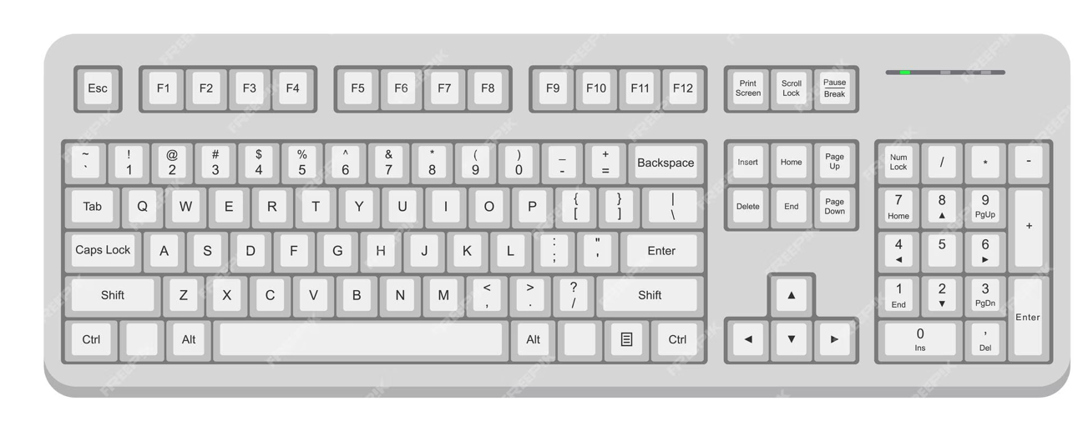

The indicator lights show when number, caps or scroll lock are turned on

The numeric pad is used like a calculator

The arrow keys control the movements of the cursor.

The modifier keys are only used together with another key.

The basic typing keys are labelled with a character (a letter, number or punctuation symbol. Pressing a key produces its character on the screen.

* 1. **The keys on a keyboard include only symbols and numbers. 🡪**
  2. **There are five arrow keys which move the cursor. 🡪**
  3. **Modifier keys work on their own. 🡪**
  4. **The keyboard has got mathematical symbols. 🡪**
  5. **More than one set of keys can control the cursor. 🡪**

1. **An IT worker (A) is answering a call from a colleague (B). Listen to the dialogue and complete it with the missing words.**

**A:** Hello, this is Tim in IT.

**B:** Hi, Tim. This is Sara. I'm calling from the **1) third** floor. I've got a

problem with my **2) keyboard**

**A:** Good morning, Sara. Is it a standard keyboard or a wireless keyboard?

**B:** It's a **3) standard** one and the delete key is stuck. I've deleted a whole page of text!

**A:** Oh dear! So first, make sure you've saved all your work. OK, now **4) unplug** the keyboard from your PC. Next, turn it over and **5) hit** it gently.

**B:** What? Are you sure?

**A:** Yes, if the keys have got dirt inside them, they sometimes get stuck.

**B:** OK. Now what?

**A:** Now plug the keyboard in again. Press the **6) enter** key and see what happens.

**B:** Alright. Hey, it's working! Thanks.

**A:** Great!

**B:** Tim, wait a minute. Now the s key isn't working. I'm pressing the key, but the **7) symbol** doesn't appear on the monitor.

**A:** Alright, I'II come and take a look. We'll try **8) cleaning** some of the keys.

**B:** Thanks. I'm in Room **9) 312**

1. **Read the dialogue in exercise 2 again and answer the questions.** 
   1. In which department does Tim work?
   2. What complaint has Sara got?
   3. What does Tim think is causing the problem?
   4. Is Sara's keyboard working by the end of the conversation?

**VOCABULARY**

1. **Match the keys in the A to the correct action in B. Write the number next to the letter.**

|  |  |  |
| --- | --- | --- |
| **A** |  | **B** |
| 1. arrow keys | …………….. | A. Changes the text to capital letters |
| 2. caps lock key | …………….. | B. Starts a new line |
| 3. delete key | …………….. | C. Advances the cursor to the next tab stop |
| 4. escape key | …………….. | D. Changes one letter to a capital or punctuation mark, or gives another option |
| 5. return key | …………….. | E. Move the cursor up, down, right or left |
| 6. shift key | …………….. | F. Removes letters or words |
| 7. tab key | …………….. | G. Cancels the current process or program running |

1. **Decide if the sentences are true or false.** 
   1. The space bar is smaller than the other keys. 🡪
   2. The control and alt keys perform actions when pressed with different letters. 🡪
   3. The backspace key deletes one position forward from the cursor. 🡪
   4. The numeric pad consists of maths symbols as well as numbers. 🡪
   5. The 12 function keys take you directly to different commands. 🡪
   6. The command key is also called the control key. 🡪
   7. A modifier key is only used in conjunction with another key. 🡪
2. 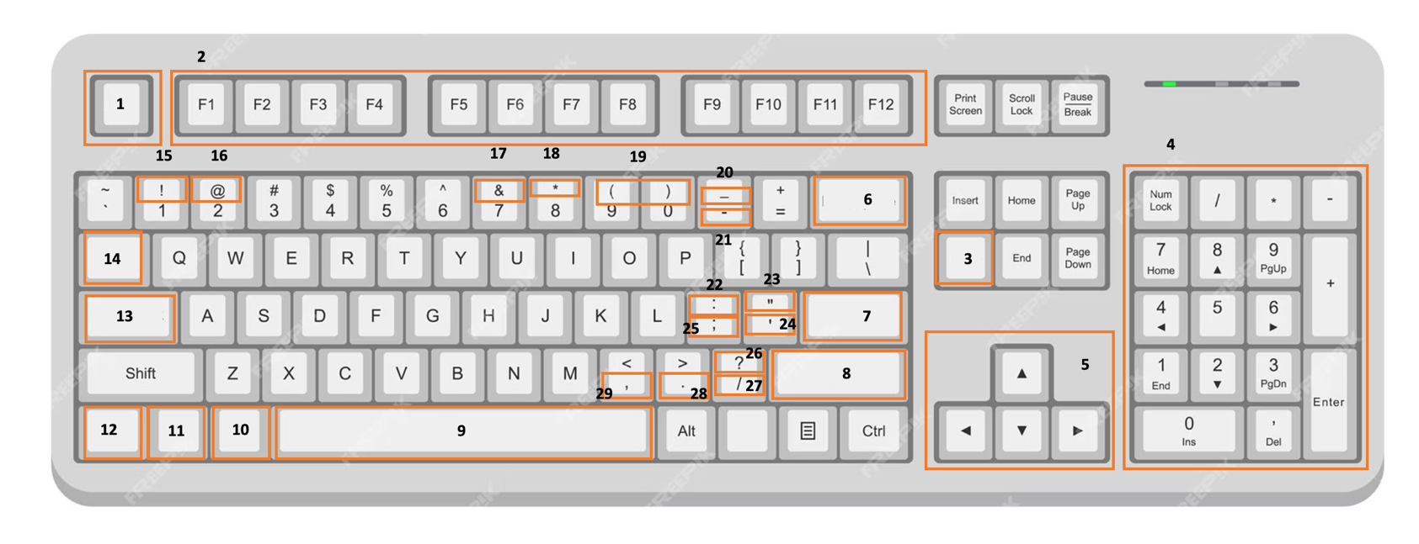**Write the name of the selected keys or punctuation mark.**

**LISTENING**

1. **An IT worker and a colleague are talking about a computer problem. Listen to their conversation and complete the report.**

**IT TECHNICIAN REPORT**

**DATE** **TIME**

3/4/18 10.00 AM

**CALLER** 🡪 **1) ………………………..** from Marketing

**PROBLEM** 🡪 The **2) ………………………..** aren’t working. Indicator lights and **3) ………………………..** still working. Possible problem with the **4) ………………………..** or might need a new **5) ………………………..**

**READING**

1. **Read the inventory of peripherals. Answer the questions.**

|  |  |
| --- | --- |
| **Johnston’s and Co.: Computer Hardware Inventory** | |
| **Type 2: Peripheralas** | |
| **Projectors** | 4 – but projector in Room 79 not working |
| **Printers**  *Laserjet 6000*  *DS 90 All-In-One*  *Deskjet 1550* | 32  12  6 – order half a dozen more from supplier |
| **Scanners**  *FUMI MR 2000* | 4 – enough? Check with design department |
| **Headsets** | 60 – received double order  Return one box of 30 to supplier |
| **Webcams** | 15 |
| **Keyboards**  *Standard*  *Wireless* | 38  12 |
| **Monitors**  *Standard*  *Large* | 28 – 5 broken monitors  31 |
| **Microphones** | None |
| **Speakers** | 6 pairs – order 1 new pair for meeting room |
| **Mouses**  *Standard*  *Wireless* | 13 (now obsolete)  46 |

* 1. **How many projectors are available for the workers to use?**
  2. **There are too many of one item. Which one?**
  3. **What is wrong with some of the monitors?**
  4. **Which piece of equipment is missing completely?**
  5. **Why isn't Johnston's going to order any more standard mouses?**

**VOCABULARY**

1. **Match the words to the picture.**

scanner / speakers / projector / microphone / stylus pen / webcam / headset / printer / gaming controller

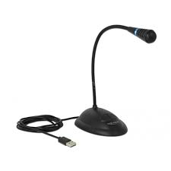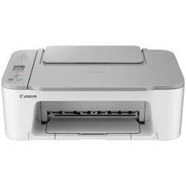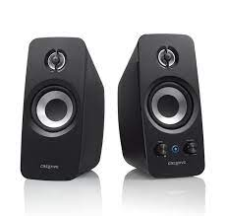

**1**

**2**

**3**

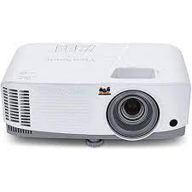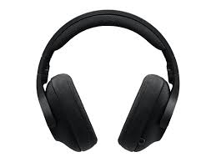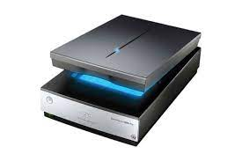

**4**

**5**

**6**

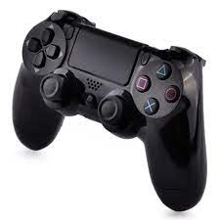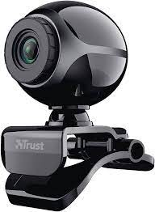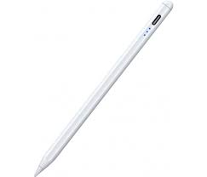

**7**

**8**

**9**



1. **Complete the sentence with the correct word.**

Flash drive / barcode scanner / remote control / touch screen / USB charger

* 1. It's got a **………………………..,** so you don't need to use a mouse.
  2. I can't reach the switch; please pass me the **………………………..**
  3. If you've got a **…………………..,** you can charge your phone on my computer.
  4. We need a **………………………..** to read all the shop's product prices.
  5. Hand in your homework to your teacher on a **………………………..**

1. **Match the sentences in A to B. Write the number next to the letter.**

|  |  |  |
| --- | --- | --- |
| **A** |  | **B** |
| **1.** That model is **obsolete**. | …… | **A.** Mine is full. |
| **2.** Can you please **order** a new flash drive for me? | …… | **B.** There are 97 in this box! |
| **3.** The fax machine is **broken**. | …… | **C.** They don't make or use it any more. |
| **4.** We're **overstocked** with mouses. | …… | **D.** We didn't bring enough to the trade exhibition. |
| **5.** We need to **reorder** with that supplier. | …… | **E.** It's not receiving information again. |
| **6.** We've **run out of** USB chargers. | …… | **F.** I can't see the words properly. |
| **7.** The printer has **run low on** ink. | …… | **G.** We last ordered with them three months ago. |

1. **Read the e-mail to the IT department. Complete the sentences with words from the exercises above.**

Dear Zoe,

Thanks for your help and cooperation with the annual inventory:

All of the 1) __ b __ __ __ __ t __ hardware is going to be replaced over the next 12 months.

In addition, the sales staff need two new 2) __ __ u __ __ s __ __ __ __ __ s for their presentations to their customers.

We have ordered a box of 3) __ e __ __ __ __ __ s and 4) __ __ c __ __ __ h __ __ __ s to improve sound quality for the help desk.

We have to replace the colour 5) __ r __ __ __ __ r in the art department because it is 6) __ __ __ k __ __ and it costs too much to fix.

The webcams we ordered last month haven't arrived, so we are going to 7) __ e __ __ __ __ r them.

John Worth

IT Manager

**GRAMMAR**

FUTURE TENSES

**Present continuous (future meaning)**

Use

1. For planned future actions related to personal arrangements. It usually includes a time reference or any evidence. 🡪 I’m spending this weekend with my family (it is planned)

**Present simple (future meaning)**

Use

1. Timetables or programmes 🡪 The train leaves at 7 o’clock in the evening.

**Future Simple**

Form

* Affirmative 🡪 Sb + will + infinitive
* Negative 🡪 Sb + will not /won’t + infinitive
* Interrogative 🡪 Will + sb + infinitive?

Use

1. Decisions taken at the moment of speaking (on-the-spot-decisions / spontaneous decisions) 🡪 It’s hot in there. I’ll open the window.
2. For future predictions based on what we believe or imagine will happen (usually with the verbs: hope, think, believe, expect, imagine..., with the expressions I’m sure, I’m afraid..., with the adverbs probably, perhaps....)
3. For promises (promise, swear), warnings, offers, threats, requests 🡪 I promise I will go on holiday next year // You should finish that report today or the boss will be angry // He hopes his manager approve his leave // We will give you a pay rise.

Time expressions 🡪 tomorrow, the day after tomorrow, next week, tonight, soon, in a week....

**Be going to**

Form

* Affirmative 🡪 Sb + verb to be in present + going to + infinitive
* Negative 🡪 Sb + verb to be in present + not + going to + infinitive
* Interrogative 🡪 Verb to be in present + sb + going to + infinitive?

Use

1. To talk about future plans which have been decided but not been completely planned and intentions 🡪 Now that she has finished school, she’s going to search for a job
2. To talk about predictions based on what we see or know (evidence) 🡪 Look out! You are going to slip on the ice.
3. **Complete the exchanges with WILL or BE GOING TO in the correct form.** 
   1. A: I can’t study; the TV is too loud.

B: Oh, sorry. I will turn it down.

* 1. A: It’s cold. I will make a cup of tea. Would you like one?

B: Yes, I will have one with two sugars, please

* 1. A: The printer has run out of black ink.

B: OK. I will go to the store room and get some.

* 1. A: What is Mr Frank’s schedule for the afternoon?

B: He is going to meet a client for lunch.

* 1. A: Rachel, did you call Mrs Jones?

B: I’m sorry, I forgot. I will do it as soon as I’ve sent this email.

* 1. Watch out, James! You is going to drop those plates
  2. I think I will go to the café for lunch. Would you like to join me?
  3. I don’t think you will have any problems when you land in Boston
  4. Look at that black cloud! It looks like it is going to rain soon.

1. **Complete the sentences using the present simple, present continuous, future simple or future be going to.** 
   1. Flights to Antarctica leave (leave) at 9:00 each morning.
   2. I promise I will be (be) back before lunch.
   3. At the research station, they serve (serve) breakfast at 8:00.
   4. I believe global warming cause (cause) sea levels to rise.
   5. This mountain bike is really cheap. I ´ll buy it (buy)!
   6. Are you doing (you / do) anything on Friday night?
   7. A: What are your plans for the weekend?

B: I am going to see (see) a film with my friends at the cinema.

* 1. A: I am so nervous about presenting my project in class.

B: Don’t worry. I am sure you will do (do) a great job.

* 1. A: Can Calvin come skiing with us this weekend?

B: No. He is working (work) at the weekend.

* 1. I don’t think I will finish (finish) my work in time to go to the game.
  2. Who do you think will win (win) the match?
  3. I think I will take (take) a nap for a while
  4. The train arrives (arrive) at 12:30.
  5. Wait! I will drive (drive) you to the station.
  6. You’re carrying too much. I will open (open) the door for you.
  7. A: Have you seen Lucy recently?

B: No, but I am meeting (meet) her for lunch today.

FUTURE FORMS WITH TIME CLAUSES

* Clauses of time are introduced by 🡪 as soon as, when, whenever, after, before, until, as, while...
* We do not use a future form after any time words. If we are talking about a present/future situation, we usually use a present simple in the time clause 🡪 I will go to the cinema when I finish my homework
* Where 🡪 question word can be followed by a future tense 🡪 When will you go to the cinema?

1. **Time clauses. Complete the following sentences using will or the present simple.** 
   1. When we go (go) shopping, I ´ll buy (buy) you something nice.
   2. I will wake up (wake up) when the alarm clock go off (go) off.
   3. After I finish (finish) my homework, I ´ll watch (watch) a film on TV.
   4. The children are going to the park. They will have (have) some ice cream while they are (be) there.
   5. By the time Sam finishes (finish) work, it will be (be) dark outside.
   6. When will you be (you/be) back from London?
   7. I will read (read) a book before I go (go) to sleep.
   8. Sharon will give (give) us the money after she gets (get) paid.
   9. We can’t leave until Helen comes (come) back.
   10. We will go (go) dancing after we have (have) dinner.

IMPERATIVE

To give commands, orders and instructions in English we use the **imperative**. The form of the verb used for the imperative is the **base form** of the main verb. It is used without a subject, although it has an understood subject “you”.

* Walk to the corner, turn right, and cross the road.

To make the negative form of the imperative we use 🡪 don´t + base form

* Don’t lose that key.

1. **Underline the imperative forms in these sentences.** 
   1. Pick up the dry cleaning today.
   2. Don’t answer the door unless your parents are home.
   3. Tell me that I’m wrong.
   4. Leave the book under my doormat.
   5. Don’t touch the thermostat.
   6. Stop making that noise.
   7. If you miss the bus, don’t take the train, call an Uber.
   8. Don´t spoil the movie, please.
   9. Turn off the lights when you leave the room.
   10. Don’t go to the toilet without asking for permission

PREPOSITIONS OF TIME

**AT**

1. Time 🡪 at 2 o’clock
2. Holidays 🡪 at Christmas, at Easter
3. In the expressions
   1. At the moment
   2. At present
   3. At dawn / noon / night / midnight
   4. At lunchtime
   5. At the weekend
   6. At that time

**IN**

1. Months 🡪 in May
2. Seasons 🡪 in winter / spring / summer / autumn
3. Years 🡪 in 2014
4. Centuries 🡪 in the 19th century
5. In the expressions
   1. In the morning / afternoon / evening
   2. In an hour
   3. In a week
   4. In the past
   5. In the future

**ON**

1. Days 🡪 on New Year’s Eve
2. Dates 🡪 on 19th August
3. Specific part of certain day 🡪 on Sunday morning
4. Adjective + day 🡪 on a hot day
5. **Complete the following sentences using IN, ON or AT.** 
   1. I have a meeting ………………………. 9 o’clock.
   2. In England, it often snows ………………………. December.
   3. The stars shine ………………………. night.
   4. I stay with my family ………………………. Christmas and we usually eat turkey ………………………. Christmas Day.
   5. Let’s meet …………………… the morning …………………… Saturday.
   6. The manager isn’t here …………………… the moment, but she will be back …………………… an hour.
   7. Her birthday is …………………… 20th December.
   8. I usually go to the beach …………………… summer.
   9. Do you have an English class …………………… Mondays?
   10. She went to the United States for the first time …………………… 2001.
   11. I wake up …………………… 7 o’clock from Monday to Friday.
   12. America was discovered …………………… 1492.